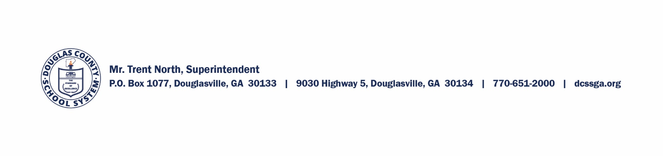
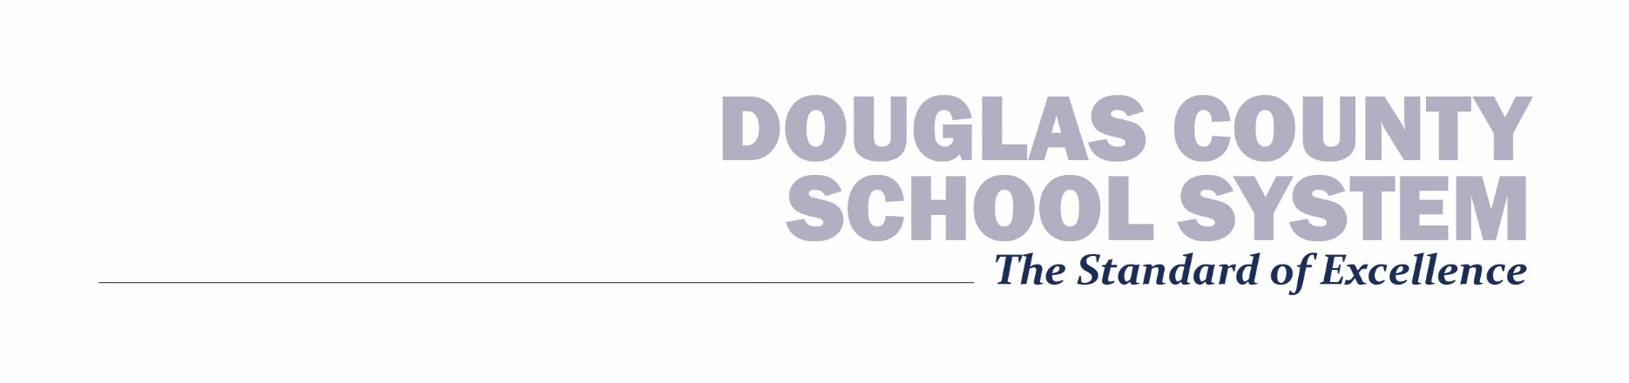
June 2020 – Return to Conditioning

There are several guidelines that we are following:
- Athletes will work out in predetermined groups of less than 20 – becomes 50 July 15, 2020.
- Athletes cannot attend camps/practices if they have a fever, determined by a thermometer reading 100.4 or higher or by subjective signs such as flushed cheeks, fatigue, extreme fussiness, chills, shivering, sweating, achiness, headache, not eating or drinking.
- Any athlete is subject to a health screening, including questions and a temperature reading.
- Parents should drop-off outside the building to limit contact. We do not encourage athletes to ride together who have not been quarantined together.
- Athletes will need to bring their own water, clearly labeled. Water fountains will not be available.
- We will sanitize and disinfect between athletes’ usage of equipment. We encourage athletes to use soap and water and/or hand sanitizer before touching their face or nose.
- We will sanitize and disinfect common spaces, such as bathrooms. We will attempt to be outdoors as much as possible.
- We will continue to follow the GA Department of Health and CDC Guidelines.

DCSS Athletic Waiver

I, the undersigned parent or guardian, do hereby grant permission for my child, _________________________________, to participate in the 2020 summer conditioning programs in the DCSS. I understand that this out-of-school activity involves risk to the participant. I further acknowledge and understand that there is a possibility that my child may sustain physical injury or illness (minimal, serious or catastrophic) in connection with his/her participation. I further acknowledge and understand that my child is assuming the risk of such physical injury or illness by his/her participation. I further release the Douglas County School System and its representatives from any claims for personal injury or illness that my child may sustain during participation in this camp. I further understand that the Douglas County School System has established rules and regulations pertaining to conduct, behavior, activities and health/hygiene of all students by which my child must abide during participation in this program, and that my child and I will be responsible for his/her failure to abide by those rules and regulations.
My child and I have read and understand the above Liability Release.
________________________________ _____________
(Parent/guardian signature) Date

